Clean Sky technologies for greener aviation in the spotlight at EASN International Conference

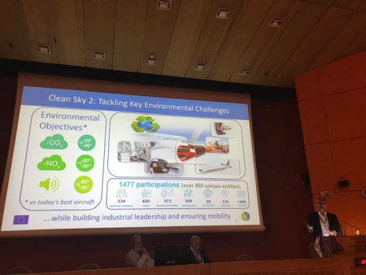

06 September 2019

Clean Sky was the focus of several presentations during the 9th EASN International Conference on Innovation in Aviation and Space, which took place this week in Athens and brought together more than 450 participants.   
    
Ron van Manen, Head of Strategic Development Unit, discussed the challenges faced by the aviation industry to sustain its role in a net-zero carbon future, and Jean-François Brouckaert, Chief Scientific Officer, gave a presentation on the future of turbofans and aircraft propulsion systems. Finally Christos Vasilakos, Clean Sky’s Policy Officer for European Structural and Investment Funds (ESIF), spoke about the innovations and technologies which have come about as a result of Clean Sky’s work on building synergies with Member States and Regions, and how the best practices and lessons learned could be put to the best possible use in a future European Clean Aviation partnership.